Akhil Garg
BNFO 300
November 30, 2014

Proposal Draft: Measurement of the relative binding of Ang-4 to the Tie-2 receptor

Introduction
The stability of blood vessels in the human body is in dynamic equilibrium: on one hand, vessels must allow small molecules in and out of capillaries, and on the other, blood serum must not leak out. This equilibrium changes as body conditions change, especially during disease. For example, during the process of inflammation, vessels become unstable and release more blood (Kennedy, 2010; Prevete, 2013). The blood, which is full of proteins and antibodies, helps to fight infection. Physical outcomes of other diseases also depend on the regulation of vessel stability—such as sepsis (Standiford, 1995), metastasis of cancers (Padua, 2008), and viral hemorrhagic infections like Ebola (Terajima, 2007). Some of these conditions are quite dangerous and need urgent treatment.
A better understanding of the mechanisms that influence capillary stability could lead to better, faster treatment for these diseases. For instance, a drug that decreases capillary permeability during sepsis could lead to better patient outcomes. The creation of such a therapy depends on comprehending the signaling pathways that control blood vessels.
The tyrosine kinase Tie-2 regulates angiogenesis (the formation of new blood vessels) and vessel stability (Gale, 1999). It is known that four ligands known as angiopoietins bind to Tie-2 (Jain, 2003). These four angiopoietins are numbered Ang-1 through Ang-4. Ang-1 and Ang-2 are better studied than Ang-3 and Ang-4. Ang-3 and Ang-4 are homologous genes found in mice and humans, respectively. Both may play a role in humans, and Ang-4 seems especially important in human lungs (Valenzuela, 1999; Lee, 2004). However, the unique effects of Ang-4 that are separate from the other angiopoietins are not known.
We can begin to understand the effects of Ang-4 by first comparing—to other angiopoietins—Ang-4 binding affinity to Tie-2. If four different ligands are influencing the Tie-2 receptor, a complex system of signaling must occur. A first step in unravelling that system is to determine to what extent Ang-4 plays a role in influencing Tie-2 phosphorylation compared to the other angiopoietins.
One way to quantify how much of each ligand will bind to Tie-2 is by the use of binding constants. A higher binding constant implies that two molecules are more likely to be bound together. The purpose of the experiment in this proposal is to generate these binding constants. To this end, the technique of surface plasmon resonance (SPR) can be used.

Experiment
SPR generates binding constants by using its namesake phenomenon, surface plasmon resonance. Briefly, as two molecules bind to each other on a thin piece of metal, light reflects differently off of the other side of the metal. This small change is measured and translated to a binding constant.
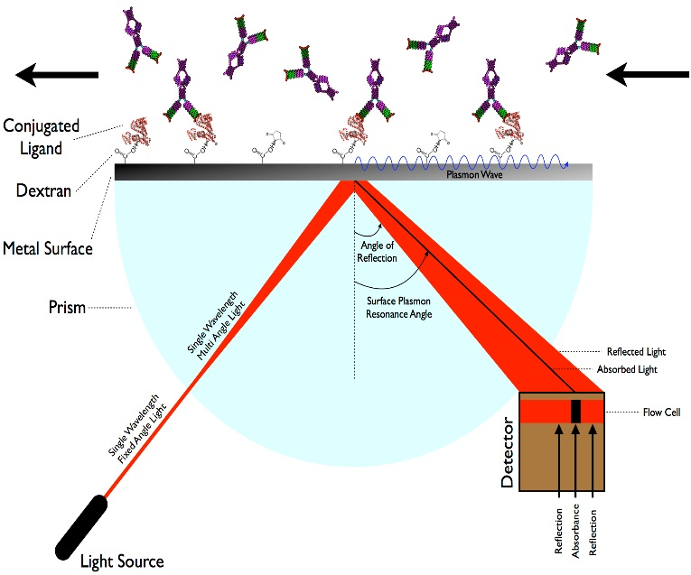
Metals have delocalized electrons on their surfaces—that is, electrons are able to move from one positive metal atom nucleus to another. These electrons move randomly about, but when a photon hits the surface of the metal, its electrons begin to oscillate at a certain frequency characteristic of the metal and whatever the metal is in contact with. A surface plasmon is a quantized oscillation of free electrons on the surface of a metal. SPR occurs when the frequency of a photon that hits the surface of a metal is the same as the frequency of the metal’s surface plasmons. A useful property of surface plasmons is that they influence the interaction of metals with light.
Figure 1: Surface plasmon resonance: the technique. The metal surface is gold, and instead of a prism, a simple piece of glass and a wide-angle light beam will be used. Tie-2 is bound to the dextran medium. As angiopoietins bind to Tie-2, the SPR angle changes. A detector measures the change, which implies the amount of binding that occurs. (Image from Sabban, 2011.)
Any molecules that are on the surface of the metal will influence the frequency of surface plasmons. If a photon hits the metal at the SPR frequency, its energy will be absorbed as a surface plasmon. Otherwise, the photon will be reflected. The absorbance is noted by a detector (see Figure 1).
This experiment will follow the procedure used by Himanen (2004). A gold film will coat a piece of glass. Gold has a high conductivity which is useful for SPR. On top of the gold is a dextran medium that contains many carboxyl groups, to which proteins can bind. Four different experiments will be conducted. In each, Tie-2 will be added to the dextran medium. Then, a continuous solution of each of the four angiopoietins (hence the four experiments) will be added to the Tie-2-coated medium.
As particles of angiopoietins bind to the Tie-2 receptor in each experiment, the frequency of surface plasmon resonance on the gold surface will change. This change is proportional to the amount of angiopoietin and Tie-2 binding that occurs. The change is measured continuously by firing a beam of light at a wide angle at the opposite side of the gold, dextran, and Tie-2 medium. At one particular angle, the photon is absorbed by the piece of gold to create plasmon waves. The absorption angle is measured by a detector (Figure 1). This angle depends on the amount of binding, so SPR can be used to determine the amount each angiopoietin binds to Tie-2 over time.
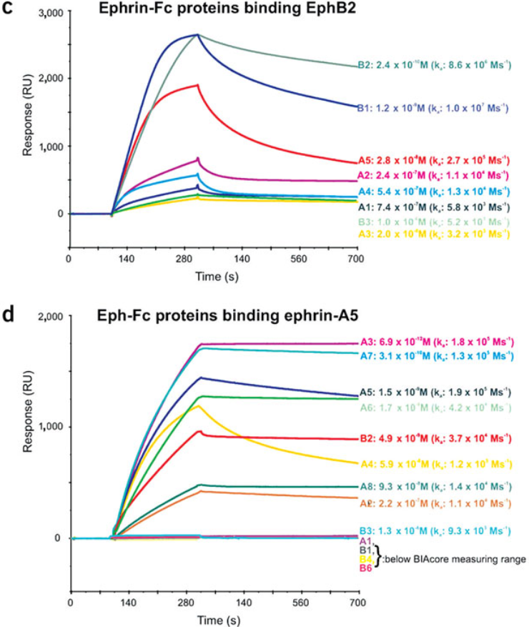
Himanen (2004) used SPR to determine binding constants between EphB2 and ephrin-A5. Those results are converted from an absorption angle to a response unit (RU), which is displayed in Figure 2. The red lines in each subfigure are the binding curves for EphB2 and wphrin-A5, and other results are also displayed on the same graphs. The first part of the curve between around 120 and 300 seconds represents analyte being added to the ligands: as more is added, more binding occurs. The second part of the curve after 300 seconds represents dissociation of the analyte after the addition is completed. The binding constant was calculated by comparing the association rate (the first curve) to the dissociation rate (the second curve). Affinity and specificity were also measured using these curves. These results show that EphB2 binds to ephrinB2 and ephrinB1 more than ephrinA5 (Figure 2c). Figure 2d shows that EphB2 binds to ephrinA5 with high affinity. The curves are also used to calculate the binding constant between EphB2 and ephrinA5. Note that the binding constant in Figure 2c is approximately 1 divided by the binding constant in Figure 2d.
Figure 2. SPR results. One RU (vertical axis) is equal to 1 pg/mm² of binding. In this proposal, I only talk about the SPR measurements of EphB2 and ephrin-A5, which are red in both sub-figures. The first section of the curve up to the “vertex” represents association of two molecules, and the second part represents dissociation. (Image from Himanen, 2004.)
Using Tie-2 and angiopoietins will likely yield similar curves and binding constants as those of Himanen (2004).

Discussion
SPR is not without its flaws (Homola, 2003). Because of the sensitive nature of the technique, slight changes on the surface of the gold foil can affect the results. All interactions between molecules and the metal may change the absorption angle of SPR and thus lead to inaccuracies in the data. For example, Tie-2 has to be immobilized to the dextran surface, while the angiopoietins must not interact with the dextran (Schuck, 1997).
Considering these limitations, the results of SPR are further limited to only show relative binding of each of the angiopoietins. However, this is a first step before more involved experiments can be completed. Knowledge of relative binding can imply the relative effect of each angiopoietin. That understanding can help give more meaningful answers to open questions such as determining the cellular effect of Ang-4. That is, determining whether it is a Tie-2 agonist or antagonist, and resolving which other signaling pathways it triggers. The entire system of signaling pathways that regulates vessel stability still needs to be untangled, and knowledge of Ang-4/Tie-2 may assist in that. Following knowledge of Ang-4 at the cellular level, in vivo studies can be performed. For example, if Ang-4 is removed in mice, what effect occurs on the capillaries? Is there more or less leakiness in vessels, specifically lung vessels? Are there other defects in the absence of Ang-4? These questions center on the unique effects of Ang-4. Determination of binding affinity is a first step before any of these questions can be answered.
Since Ang-4 seems to localize to the lungs (Valenzuela, 1999), therapy that employs Ang-4 could be more specific to the lungs. A better awareness of Ang-4 could lead to new therapies for the vast number of diseases that rely on or have some effect on the maintenance of blood vessels.

References
Gale, N. W.; Yancopoulos, G. D. (1999). Growth factors acting via endothelial cell-specific receptor tyrosine kinases: VEGFs, angiopoietins, and ephrins in vascular development. Genes and Development 13(9): 1055-1056. http://www.ncbi.nlm.nih.gov/pubmed/10323857
Himanen, J.-P.; et al. (2004). Repelling class discrimination: ephrin-A5 binds to and activates EphB2 receptor signaling. Nature Neuroscience 7(5): 501-509. http://www.ncbi.nlm.nih.gov/pubmed/15107857
Homola, J.; et al. (1999). Surface plasmon resonance sensors: review. Sensors and Actuators B: Chemical 54(1): 3-15. http://www.sciencedirect.com/science/article/pii/S0925400598003219
Jain, R. K. (2003). Molecular regulation of vessel maturation. Nature Medicine 9(6): 685-693. http://www.ncbi.nlm.nih.gov/pubmed/12778167
Kennedy, A.; et al. (2010). Angiogenesis and blood vessel stability in inflammatory arthritis. Arthritis and Rheumatism 62(3): 711-721. http://www.ncbi.nlm.nih.gov/pubmed/20187131
Lee, H. J.; et al. (2004). Biological characterization of angiopoietin-3 and angiopoietin-4. FASEB Journal 18(11): 1200-1208. http://www.ncbi.nlm.nih.gov/pubmed/15284220
Padua, D.; et al. (2008). TGFbeta primes breast tumors for lung metastasis seeding through angiopoietin-like 4. Cell 133(1): 66-77. http://www.ncbi.nlm.nih.gov/pubmed/18394990
Prevete, N.; et al. (2013). Expression and function of Angiopoietins and their tie receptors in human basophils and mast cells. Journal of Biological Regulators and Homeostatic Agents 27(3): 827-839. http://www.ncbi.nlm.nih.gov/pubmed/24152847
Sabban, S. (2011). Development of an in vitro model system for studying the interaction of Equus caballus IgE with its high-affinity FcεRI receptor. Electronic Thesis, University of Sheffield. http://etheses.whiterose.ac.uk/2040/2/Sabban,_Sari.pdf
Shuck, P. (1997). Use of surface plasmon resonance to probe the equilibrium and dynamic aspects of interactions between biological macromolecules. Annual Review of Biophysics and Biomolecular Structure 26:541-566. http://www.ncbi.nlm.nih.gov/pubmed/9241429
Standiford, T. J.; et al. (1995). Macrophage inflammatory protein-1 alpha mediates lung leukocyte recruitment, lung capillary leak, and early mortality in murine endotoxemia. Journal of Immunology 155(3): 1515-1524. http://www.ncbi.nlm.nih.gov/pubmed/7636213
Terajima, M.; et al. (2007). Immunopathogenesis of hantavirus pulmonary syndrome and hemorrhagic fever with renal syndrome: Do CD8+ T cells trigger capillary leakage in viral hemorrhagic fevers?. Immunology Letters 113(2): 117-120. http://www.ncbi.nlm.nih.gov/pubmed/17897725
Valenzuela, D. M.; et al. (1999). Angiopoietins 3 and 4: Diverging gene counterparts in mice and humans. Proceedings of the National Academy of Sciences of the United States of America 96(5): 1904-1909. http://www.ncbi.nlm.nih.gov/pubmed/10051567

